Hello Dr. McKinney, I was able to figure out the problem with Formatting Maps section (it was on Pages 87-93 and not on Page 83-84) in the Tutorial PDF. Yes, it is because of the different versions of PowerBI we are using. The following is the correct way to format the map the way author has done in Step 15 Solution.

1. This is the focused mode for the Filled Map showing the STATES field as axis. Note: This does not have the Advanced Formatting option that is mentioned in the Tutorial pdf.

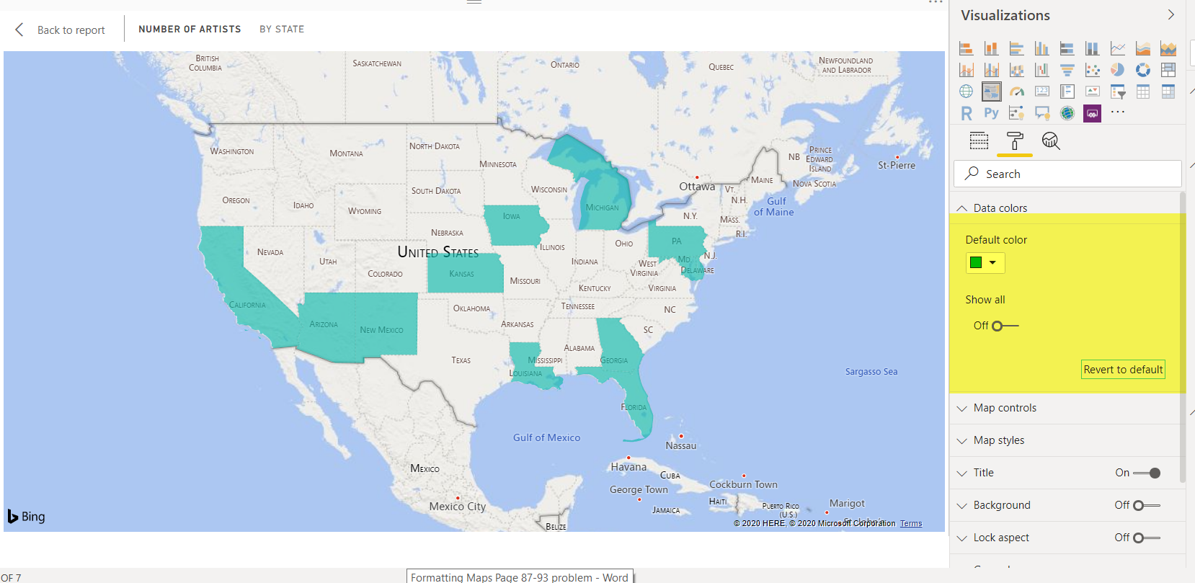

1. However, you can get to the Advanced Formatting screen by Right Clicking next to where it says default color and clicking on Conditional Formatting as shown in the screenshot below.

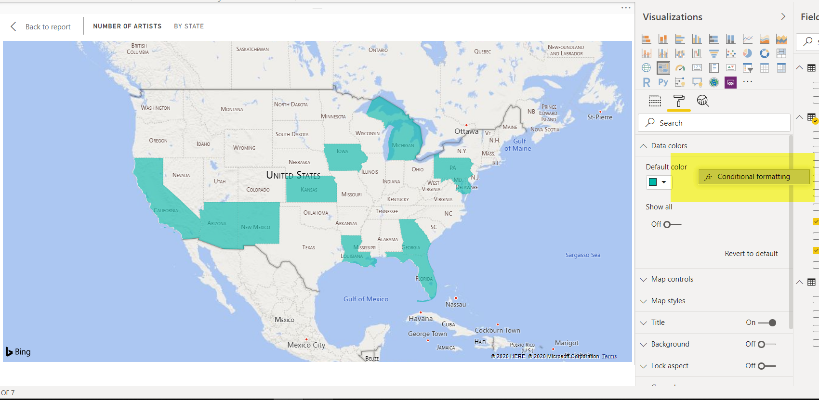

1. Once you click on the Conditional Formatting button, this window shows up.

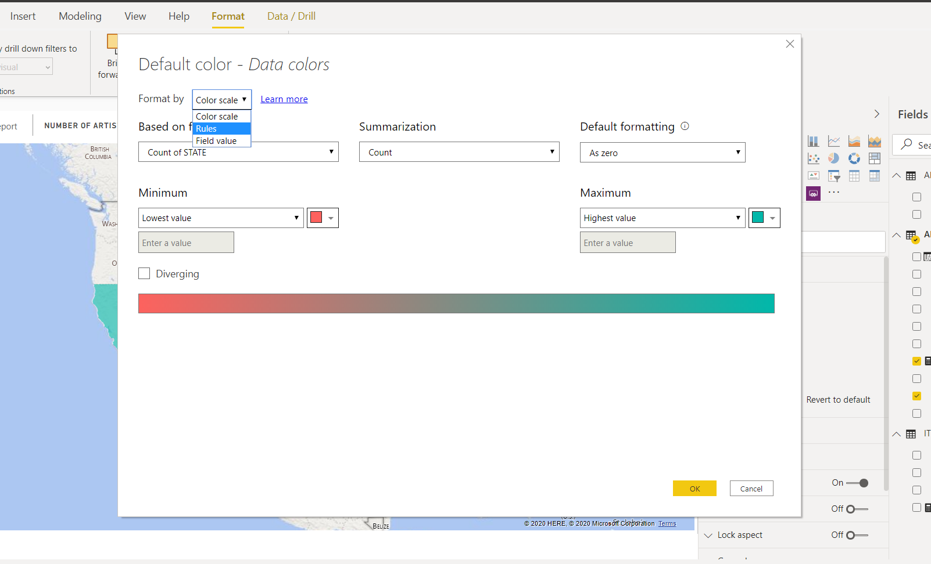

1. Now if we want to format the Filled Map Exactly like the author did in Step 15 Solution, please follow along.
2. Select “Rules” in the dropdown for “Format By”. Then in the “Based on the Field” dropdown select “Number of Artists” Field. The screen will show up like this.

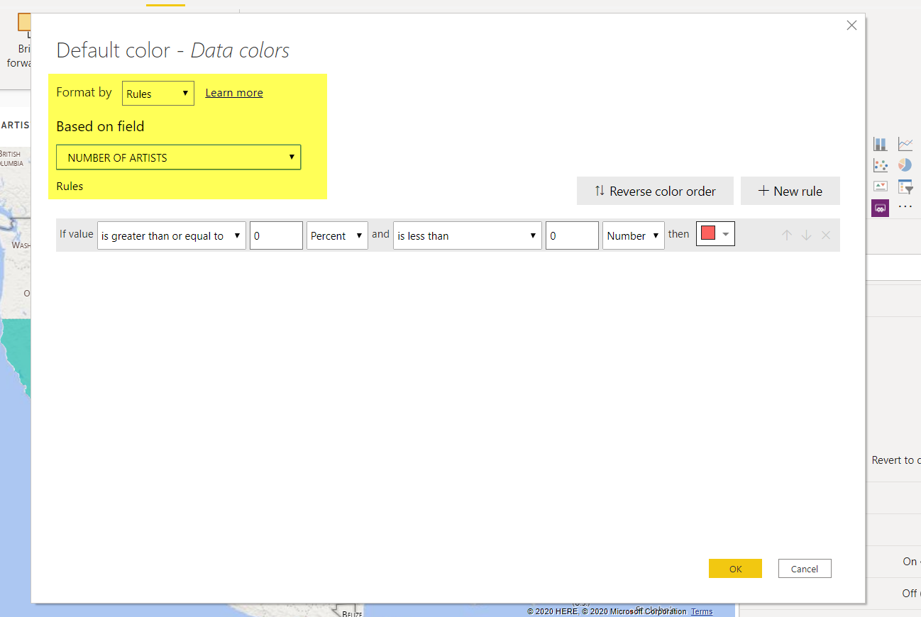

1. Now to exactly format this map as shown in Step 15 solution. I added the following rules.

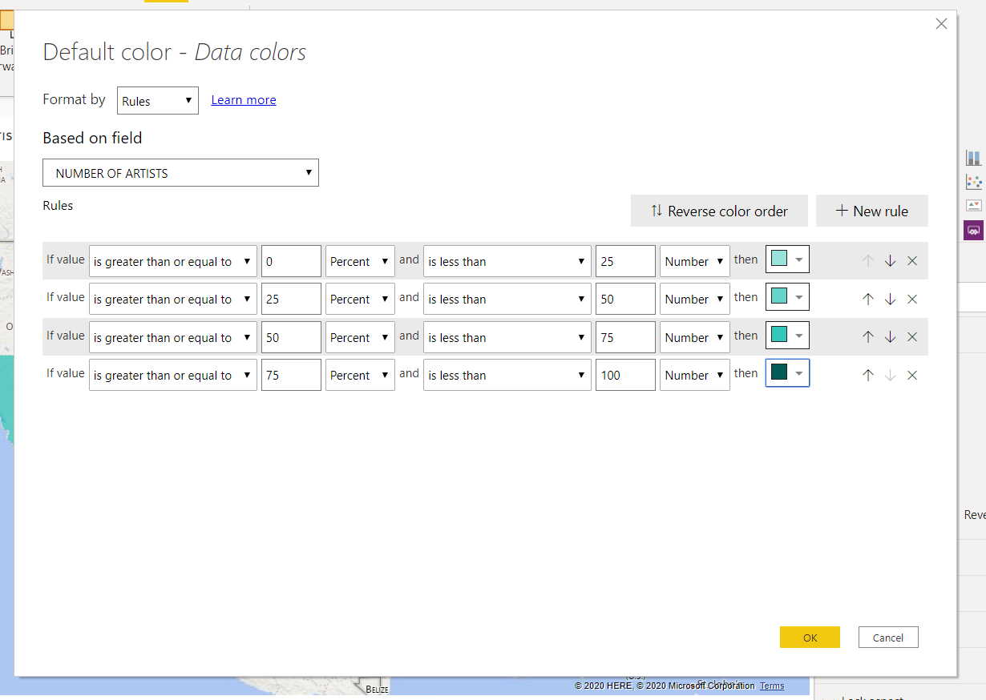

1. The map shows this once I click OK.

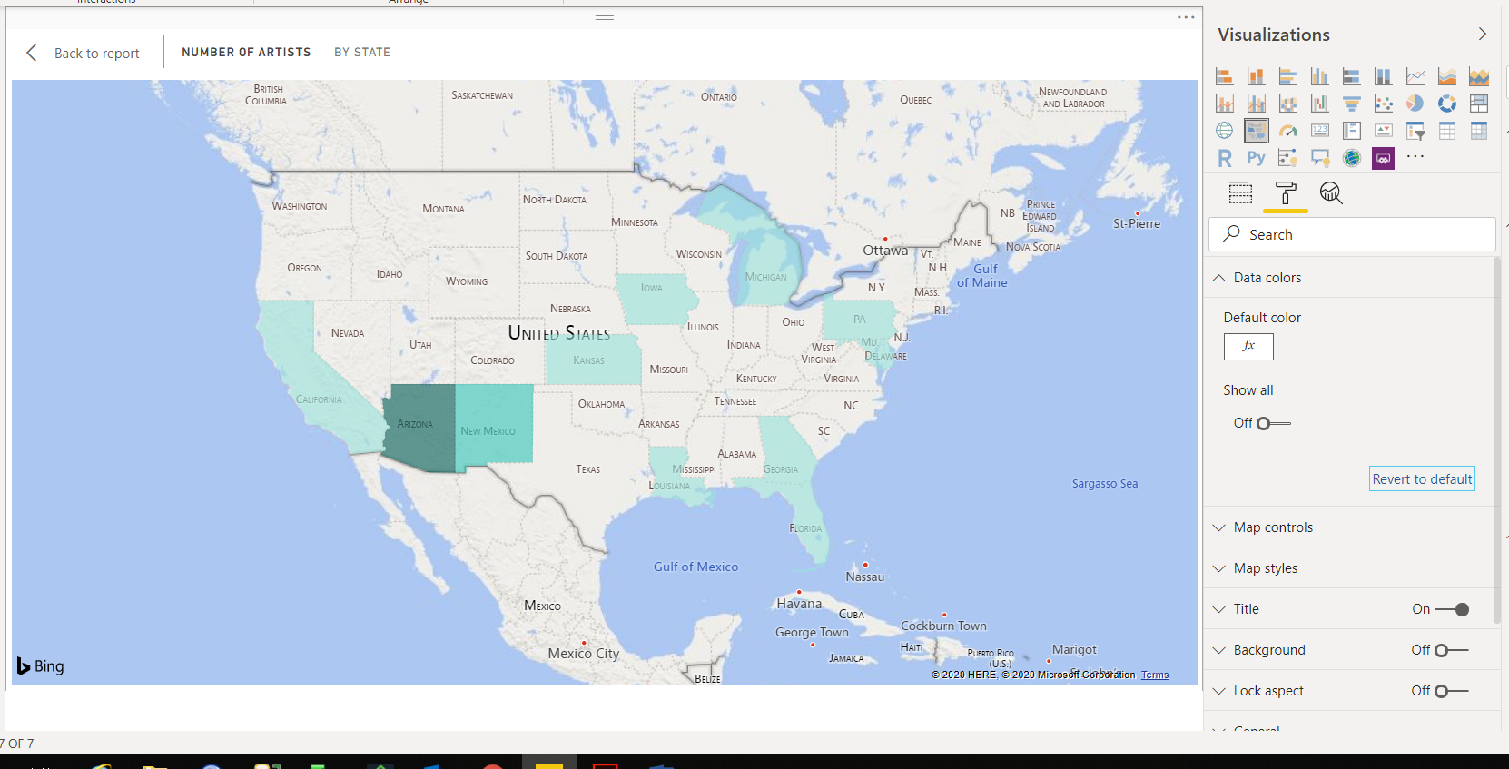

Similarly, we can format the bubble map also. Here is an example of my own formatting of the bubble map.

1. I have selected as “Number of Items Types” as Size of the bubbles and Location as “Address”.

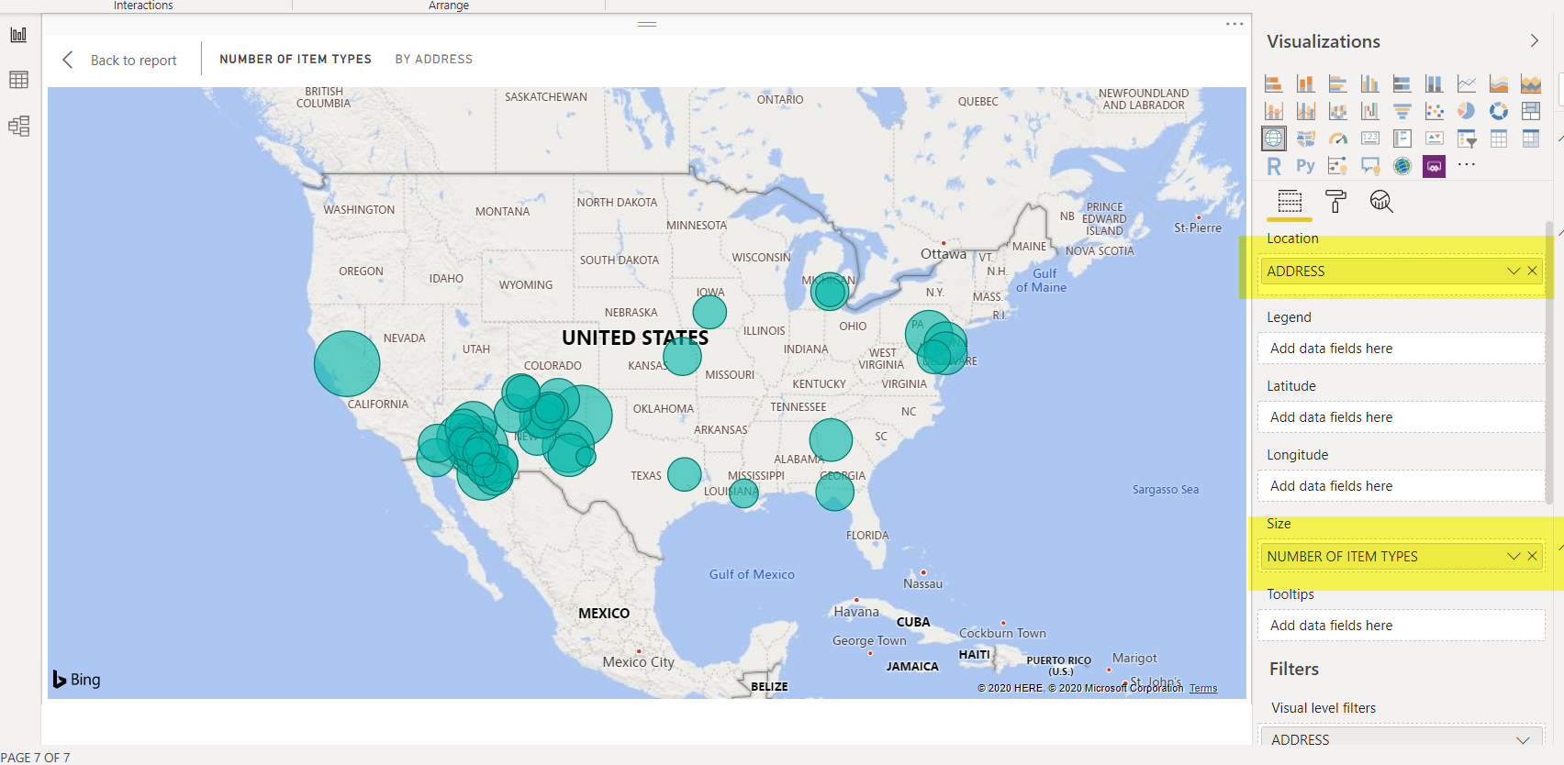

1. Now to change colors of the bubble we follow the steps similar to what we did in filled map formatting. Go to the formatting tab and expand Data Colors tab. Then right click next to where it says Default Colors and click on Conditional Formatting.

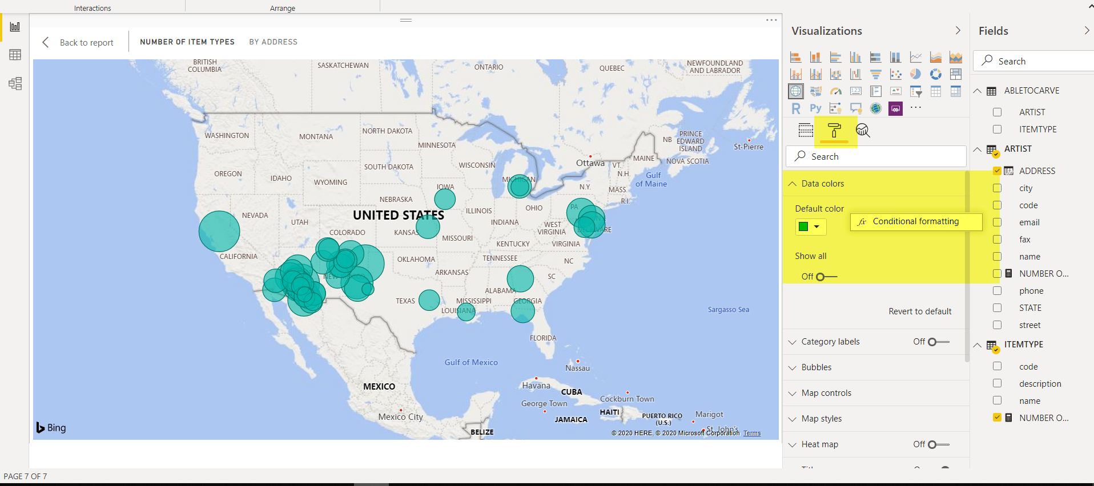

1. Just to do something different than what we did in filled map formatting, I selected “Color Scalre” in the dropdown for “Format By”. Then in the “Based on the Field” dropdown select “Number of Item Types” Field. Check Diverging just to make it more colorful. The screen will show up like this. Click OK.

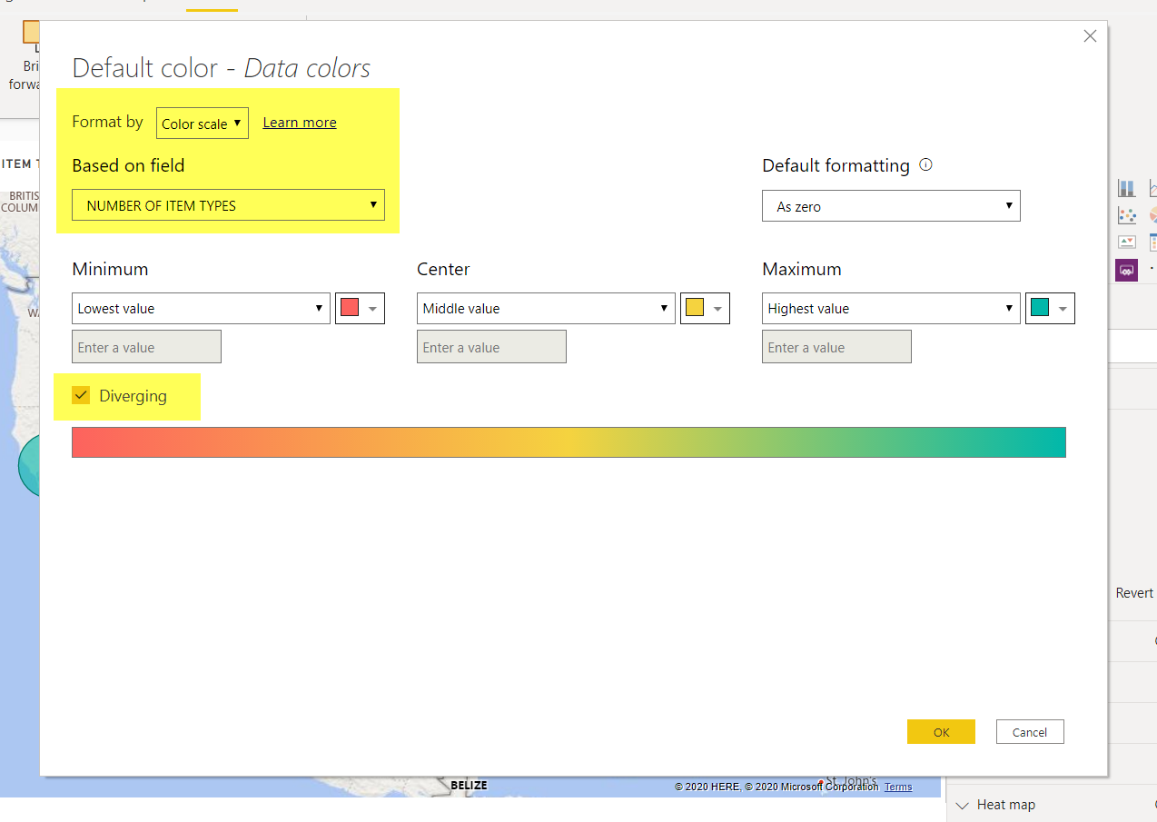

1. And Voila!

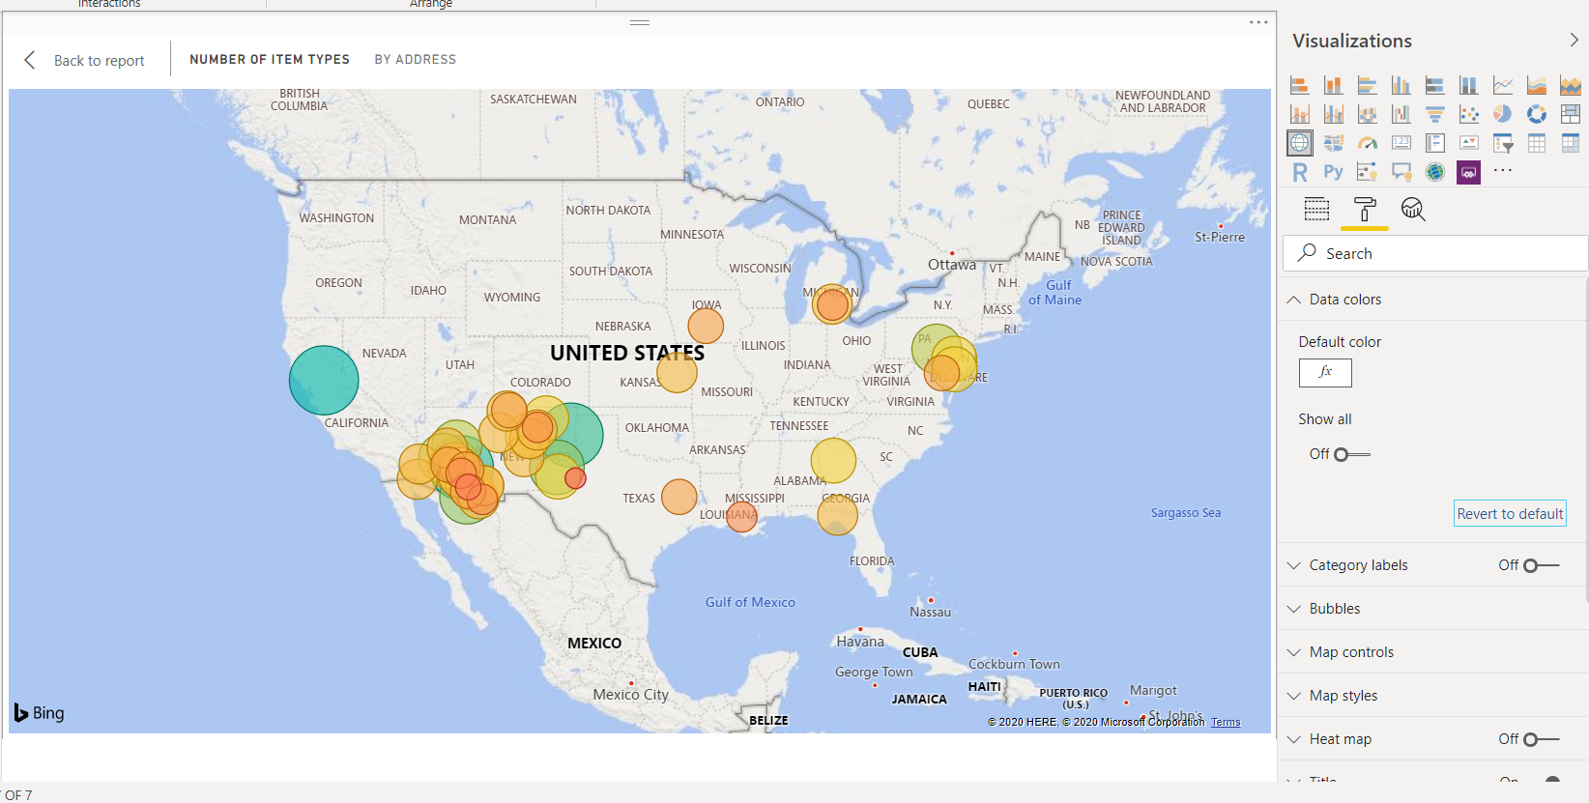

Page 131 Problem

The problem of uploading data from the CUSTOMERDATA.accdb file. This problem occurs if you do not have MS Access set up properly. The solution to this problem is given in Appendix 1 of the Tutorial pdf.

Basically, you upload 2 additional files, CUSTOMERDATA.CSV and ITEM-CUSTOMER.CSV. Both are in the files section on Canvas in the PowerBI folder.

Note: when I say upload, I mean the Get Data step you do in PowerBI.